**EMPLOYABILITY**

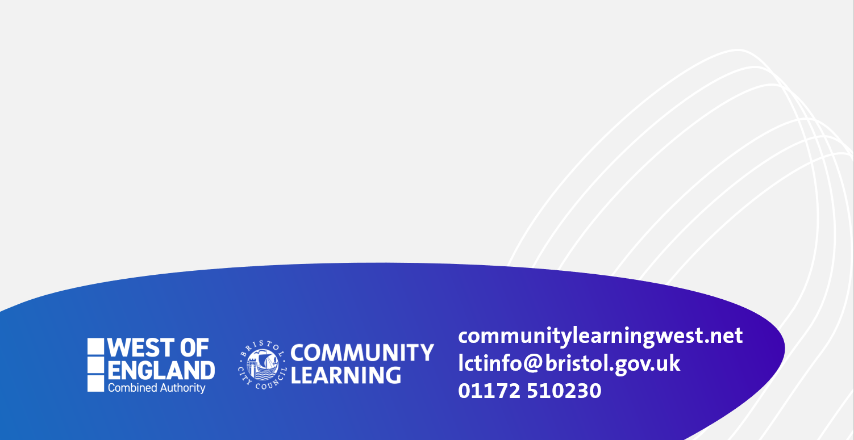

**Date:2nd December 2025**

**Times:9.30 to 14.30pm**

**Venue: Avonmouth Community Centre**

* **Find out about the skills needed and get an overview of the sector for working within adult settings or children and young people’s settings**
* **Leading to:**
  + **Level 1 Award in Health and Social Care Adults or Children’s and Young People’s Settings**
  + **Employability sessions to find out about job opportunities and training.**

**Contact: Email: shani.smith@bristol.gov.uk**

**Eligibility: Adults aged 19 years plus with few or no formal qualifications, and/or without a GCSE in English A* to C grade or equivalent.**

**This short course is in a Covid-Secure classroom.**

**Contact: suzanne.gaffney@bristol.gov.uk** **Phone: 07887451776**

**Eligibility: Adults aged 19 years plus with few or no formal qualifications, or without a GCSE in English A to C grade or equivalent.**

**4 WEEK INTRODUCTION TO HEALTH & SOCIAL CARE**

**(Adults and Children’s settings)**