**RECREATION ASSISTANT**

RECRUITMENT OPPORTUNITY

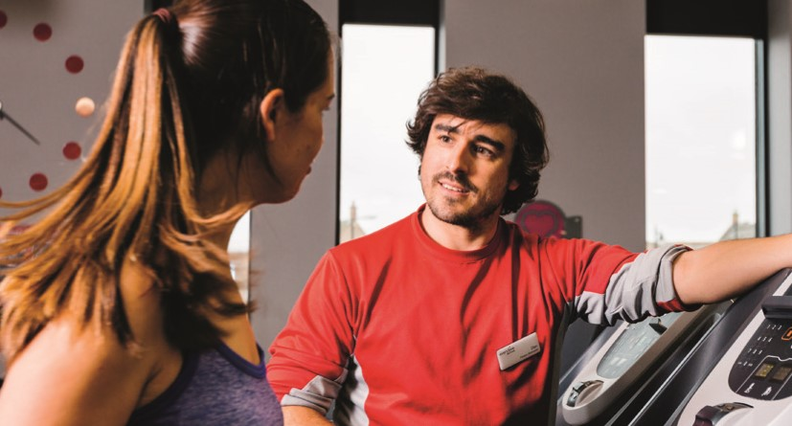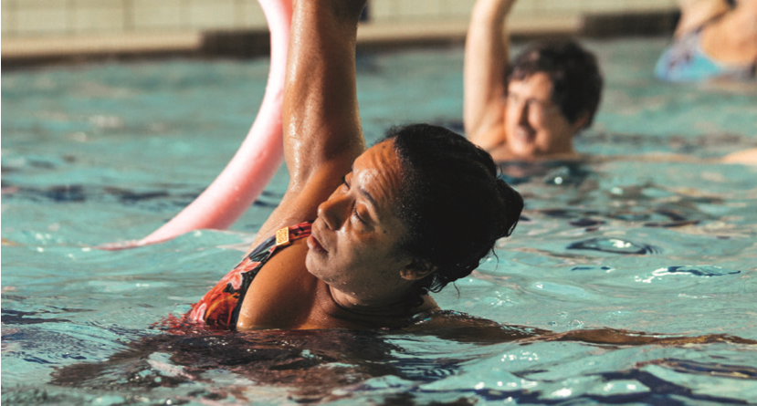

RECRUITMENT OPPORTUNITY

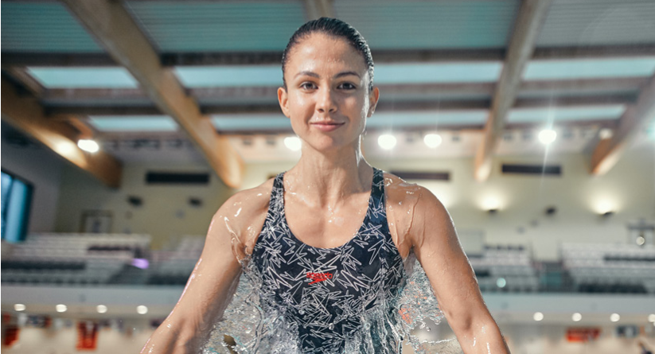

**Bristol South Swimming Pool**

**Full time, Part Time & Casual positions available – Competitive salary**

**Everyone Active is currently seeking an ambitious and self-motivated Individual to take on this role and embrace our brand mission of 30 minutes of activity 5 times a week**

**The successful candidate will be supporting health and safety operations, driving customer service excellence and be part of a diverse motivated team**

**We need an Recreation Assistant who will…**

* **Be focused on delivering excellent customer service standards**
* **Provide safe and effective pool supervision**
* **Be part of a motivated team fully embracing our company values**
* **Ensure high levels of cleanliness and housekeeping are maintained within the centre**
* **Support the varied programme of activities and sessions**
* **Effectively communicate with other team members**

**National Pool Lifeguard qualification is required but training towards the qualification can be arranged. First Aid at Work & coaching qualifications are desirable. This position will involve day, evening and weekend work including public holidays.** **We will complete a DBS check prior to starting in this role**

**What can we do for you?**

**Well, along with a competitive salary and opportunities for development, you’ll also get to enjoy working in a vibrant, exciting and friendly environment. Furthermore, as an added bonus, you and a partner/children will also get to enjoy free membership to our 220 plus centres nationwide.**

**If this sounds like you, we’d love you to get in touch. Simply email your CV and covering letter to Kurtis Ward at Kurtisward@everyoneactive.com**

**Closing date: 18th January 2024**

**BRISTOL SOUTH SWIMMING POOL**

**Dean Lane, Bedminster, BS3 1BS**