We each take

responsibility for working in an honest, fair,

respectful and

professional way

Our decisions and actions are based on theSocial Model of Disability and the needs of our members and

Customers

We have the

courage to lead change and shape a new and

exciting

future

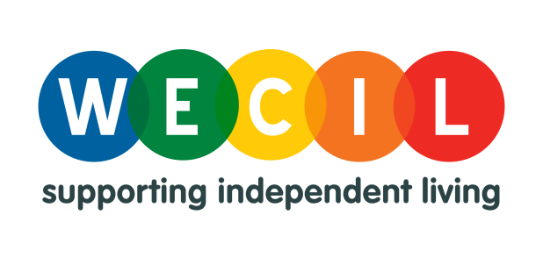

**WECIL Charter**

We accept things

do not always

work first time and learn from our

experiences focusing on the

solutions not the problems

The things that we do and the words that we say always reflect on the organisation in a positive way

We accept

challenges with a ‘can do’ attitude and support each other to get the best outcome