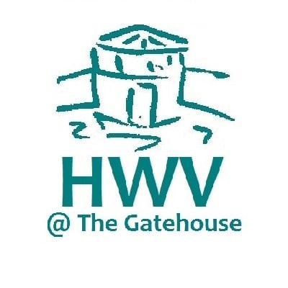
Job Opportunity
For a Part-time Receptionist @
The Gatehouse Centre
We have an exciting new vacancy starting at the beginning of September.
The hours will be Tuesday 1.30pm -5.00pm and Thursday 8.30am –5.00pm (30 minute lunch break) plus other cover when needed.
This is an opportunity for someone who has excellent people skills, some IT experience, and is looking for a few hours a week to learn new skills and be part of a friendly, busy team. Rate of pay £9.70 an hour.
Close date Friday 24th June at 5.00pm with interviews early July.
Please apply by email: gatehouse@hwv.org.uk or call 0117 9781708

