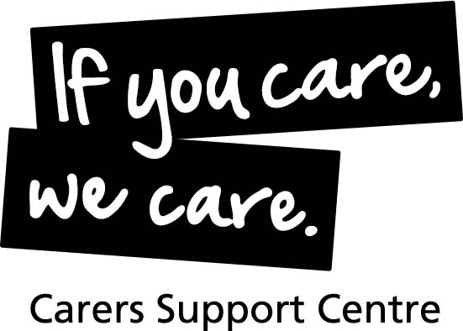

Opportunities available to help make life better for carers

Carers Support Centre (CSC) Bristol and South Gloucestershire provides a wide range of information, advice and support services for unpaid adult and young (children) carers.

A carer is someone who provides support to family or friends who could not manage without this help. This could be caring for a relative, partner or friend who is ill, frail, disabled or has mental health or substance misuse problems. All the care they give is unpaid. Three out of five people in the UK will become carers at some time in their lives.

We currently have a Fixed Term vacancy within our Health Team to work with local hospital trusts to support cares and work with NHS staff to ensure that services are carer focused.

Hospital Carer Liaison Worker - Fixed Term until the 31st of March 2023.

37.5 hours per week (Five days Monday - Friday)

Salary £23,824 per annum.

Main Aims of Role.

- To be a key reference point on carers issues.

- Work with Health professionals to Identify carers and provide support, ensuring that the carers voice is heard and that they are seen as expert partners in the whole care process, including decision-making.

- Raise carer awareness in hospital settings, particularly with nursing staff, discharge and social work teams, through training and other activities.

- Enable carers to access further support which will improve their quality of life.

- Ensure carers from all communities have access to appropriate services and support.

If you would like to know more about this role, please call 07825 299112 for further information.

For an application pack, please visit our website www.carerssupportcentre.org.uk/vacancies. Alternatively, you can submit a CV along with a covering letter detailing how you meet the criteria required on the job description/person specification.

If you do not have access to the internet please call our 24-hour answer phone service on 0117 9589973 or email: recruitment@carerssupportcentre.org.uk

Closing date Friday 1st July 2022 @ 12 noon

Interview date: Thursday 14th July 2022.

Registered Charity Number: 1063226

We are an Equal Opportunities employer, and our workplace is free of barriers and fully accessible for people with disabilities. We are committed to safeguarding children, young people and vulnerable adults; from recruitment of staff through to supporting our team working with families and carers in crisis.

