

**FAMILY LEARNING**

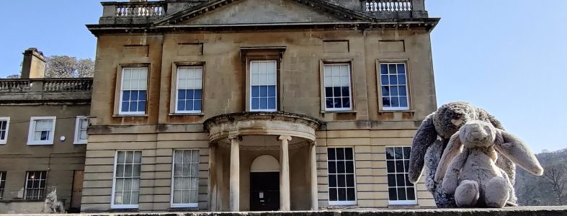

**STARTS WEDNESDAY 15th JUNE, 10-12 pm, 4 sessions**

**BLAISE MUSEUM HOUSE, HENBURY ROAD, BS10 7QS**

* **Explore how to get the most out of a family visit to Blaise Museum House and Estate in Lawrence Weston/Henbury.**
* **Spend time together and join in with fun, family-friendly crafts and activities inspired by Blaise. Themes include nature, archaeology, giants and more.**
* **Enjoy what the museum and great outdoors/estate has to offer parents/carers and your under 5s.**
* **Find out about other family activities and opportunities.**

The museum will be closed to the public whilst the course is running. Refreshments will be available from 10am.

**Contact: Suzanne to book a place and for more information** [**suzanne.gaffney@bristol.gov.uk**](mailto:suzanne.gaffney@bristol.gov.uk)**, 07887451776.**

**Who can join: Adults aged 19 years plus with few or no formal qualifications with one or more children under 5 – please bring your little ones!**

**This short course is in a Covid-Secure classroom.**

**Contact: suzanne.gaffney@bristol.gov.uk** **Phone: 07887451776**

**Eligibility: Adults aged 19 years plus with few or no formal qualifications, or without a GCSE in English A to C grade or equivalent.**

**FAMILY FUN AT THE MUSEUM -free course for parents/carers & under 5s**