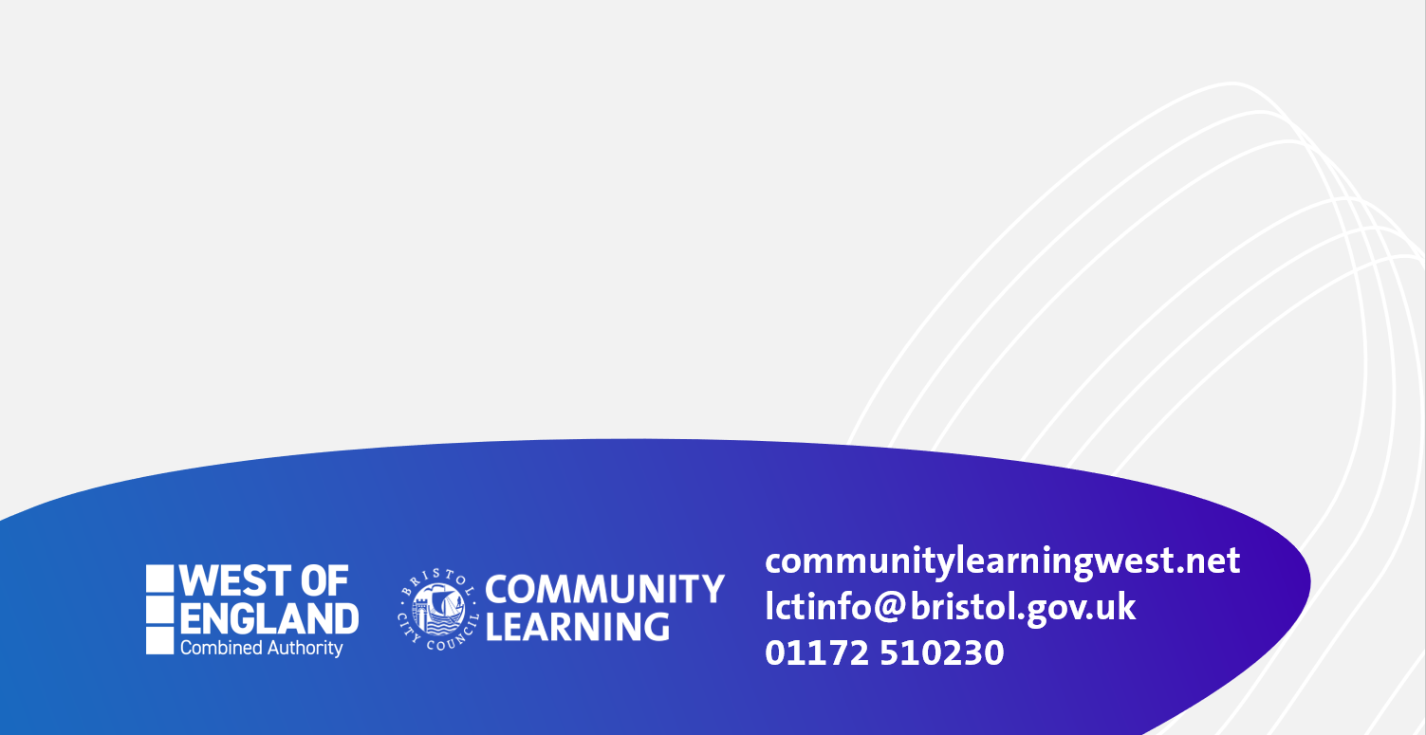

**FUNCTIONAL SKILLS**



**FREE 9 week course for adults**

**from Monday 16th May-18th July, 1-3pm**

**LONG CROSS CHILDREN’S CENTRE, LAWRENCE WESTON, BS11 0LP**

**BRUSH UP YOUR ENGLISH FOR WORK**

* **Join a small, friendly, local course, meet people and build your confidence.**
* **Improve your English for work or home; especially writing CVs, formal letters and applications. Brush up on your punctuation for formal writing.**
* **Improve your interview skills and confidence in speaking in formal meetings.**
* **Suitable for Entry Level 3 plus learners. This is not an ESOL course.**
* **Find out about progression to other follow- on courses., including Functional Skills English.**

**Contact: suzanne.gaffney@bristol.gov.uk** **Phone: 07887451776**

**Eligibility: Adults aged 19 years plus with few or no formal qualifications, and/or without a GCSE in English A* to C grade or equivalent.**